Dataset Analysis using SQL workbench

Dataset 2 -> mi_ecommerce

1. Calculate revenue by product
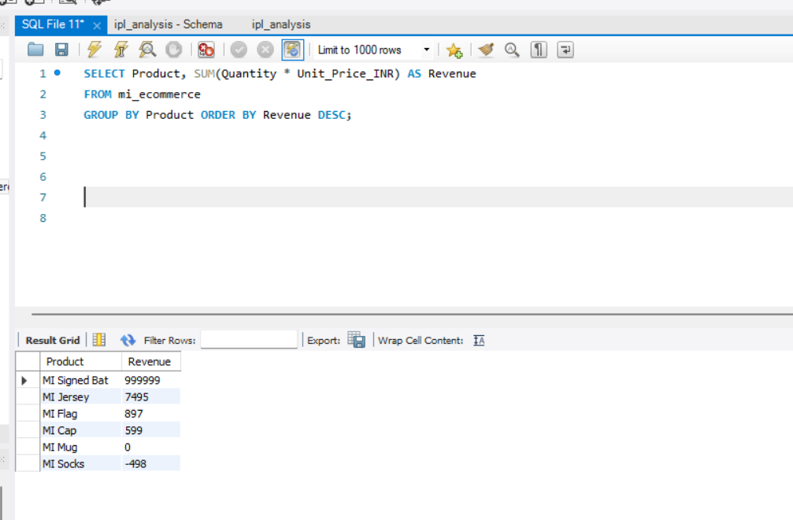

2. Find the top-selling products by quantity
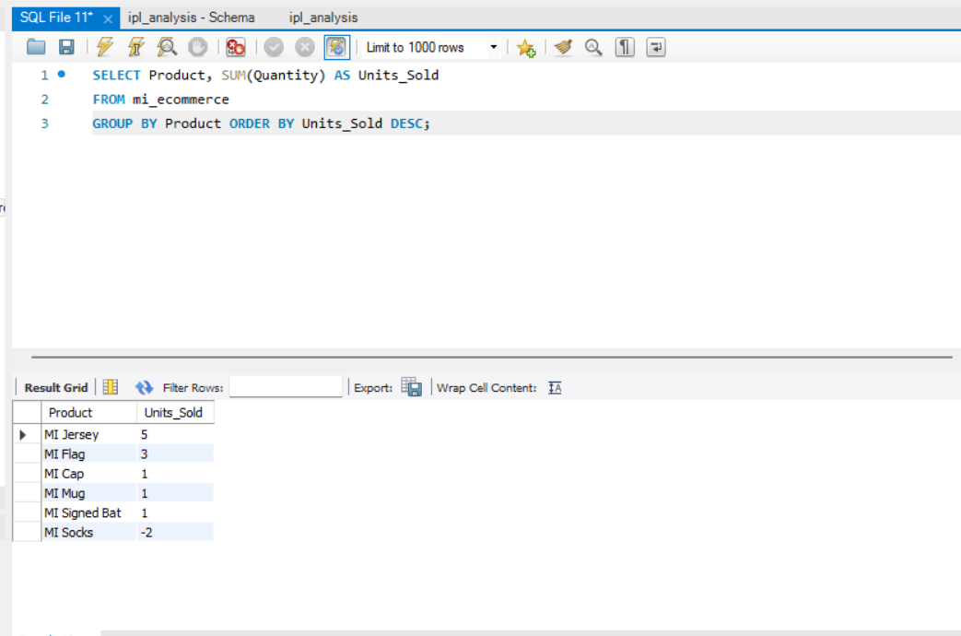

3. Calculate total sales by city
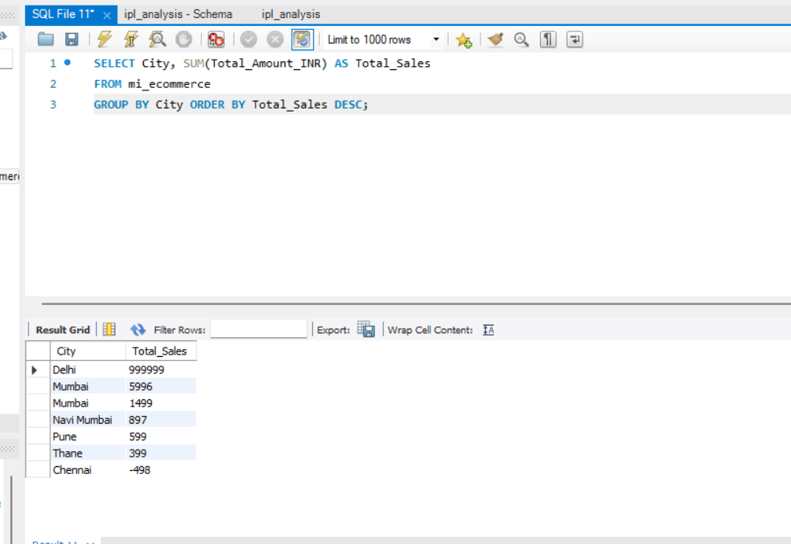
4. Analyze orders by payment method
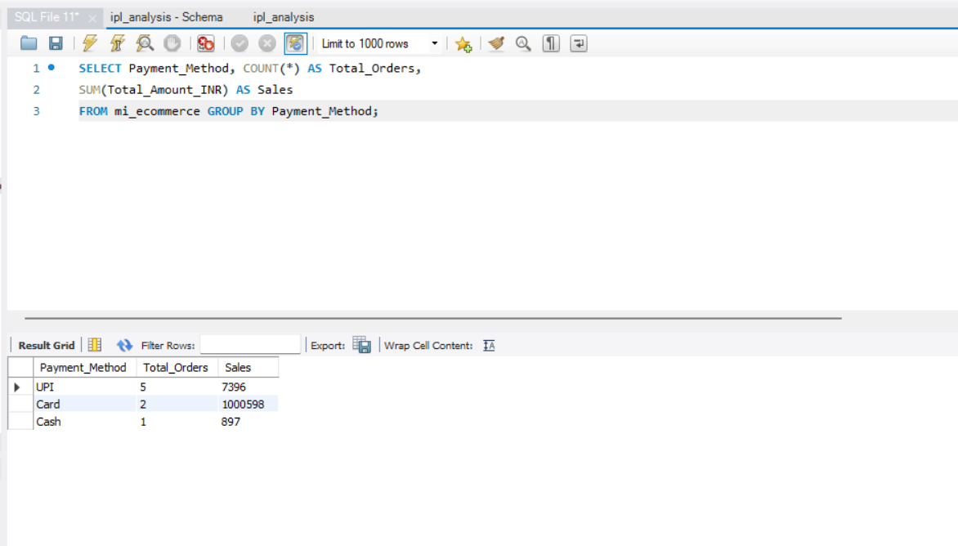

5. Compare sales by order status
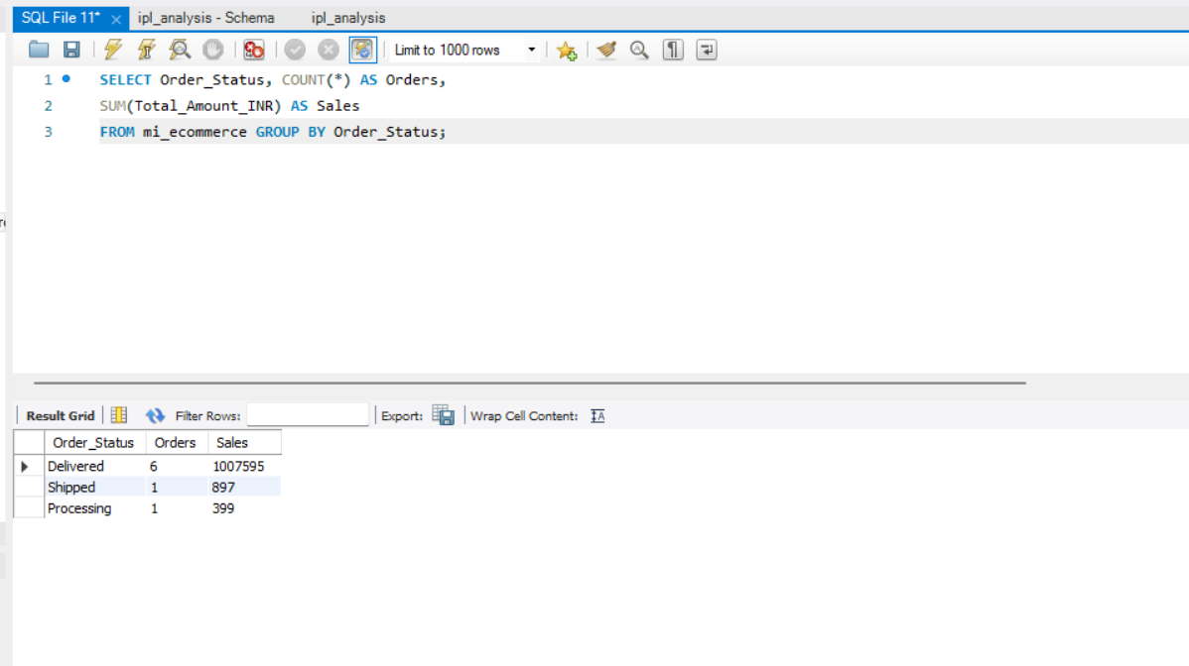

6. Find orders above the average order value
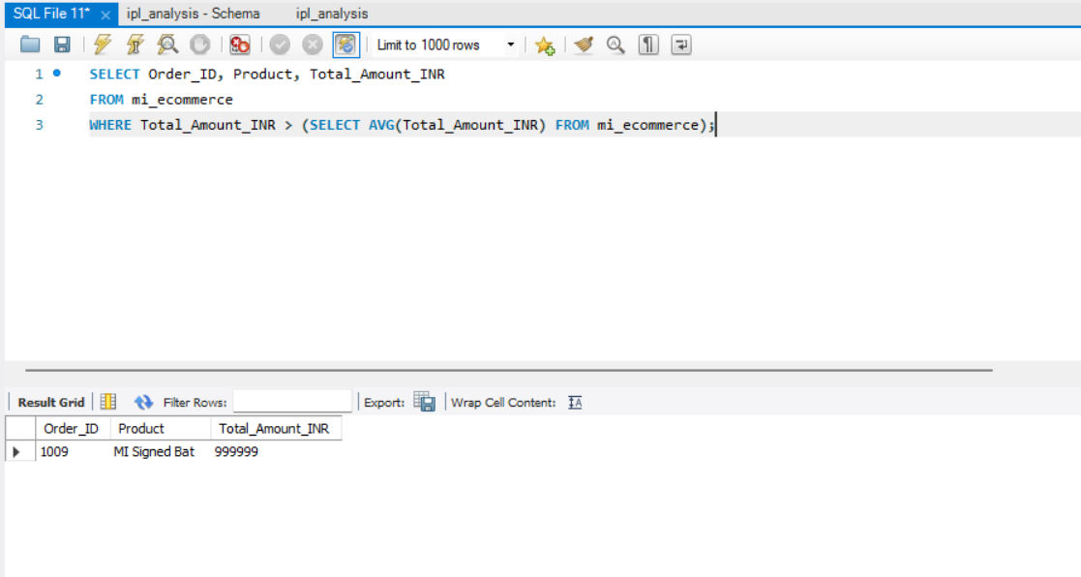

7. Categorize orders by value
